Old Chiswick Protection Society (OCPS)

Chiswick Eyot as an historic withy bed (osier holt)

As is well known, the willows (osiers) on Chiswick Eyot have been used at least since 1800 as a source of ‘withies’ (flexible willow branches) for the weaving of baskets (e.g. Clegg 1995). For these branches to be thin and flexible enough to weave such items, they would have been cut from the new growth of stems each year. The photographs of 1927 (Fig.1)
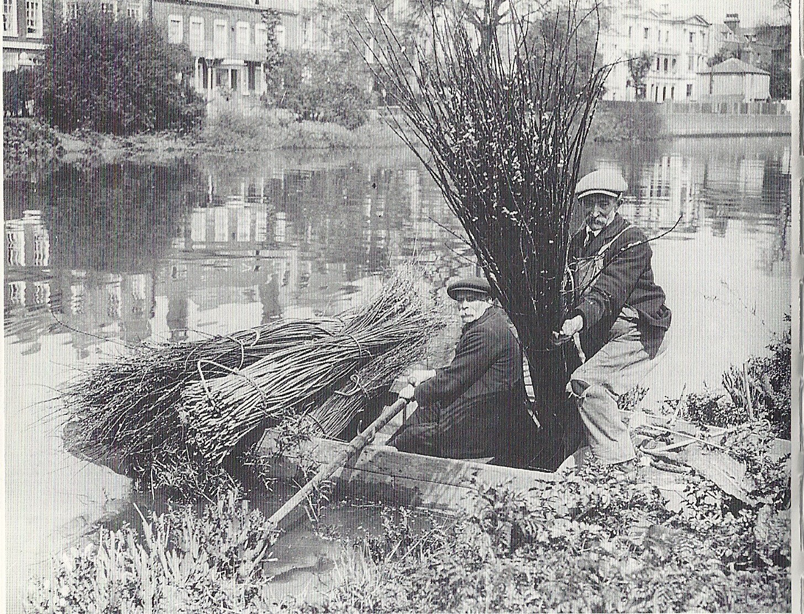
Figure 1 Withy cutters on Chiswick Eyot in 1927
clearly show thin withies which could only be formed from a year’s growth.

In the past, to produce withies, osiers were often ‘coppiced’ – that is, the new growth was cut back each year to about one foot high with ‘sharp-edged hooks’ (Robinson 1875), creating a ‘stool’ which was left to re-grow. The beds would have been weeded three to four times a year (Robinson 1875).

From numerous engravings, photographs and paintings going back to the mid 18th c. (e.g. Figs 2, 3, 4, 5, 6 & 7), it can be clearly seen that almost all of Chiswick Eyot has always been covered only with low growth.
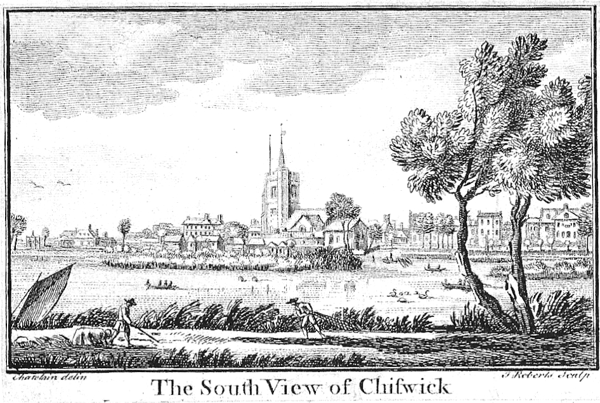
Figure 2 Print from 1750 showing Eyot on right with low-growing shrubs, possibly coppiced osiers

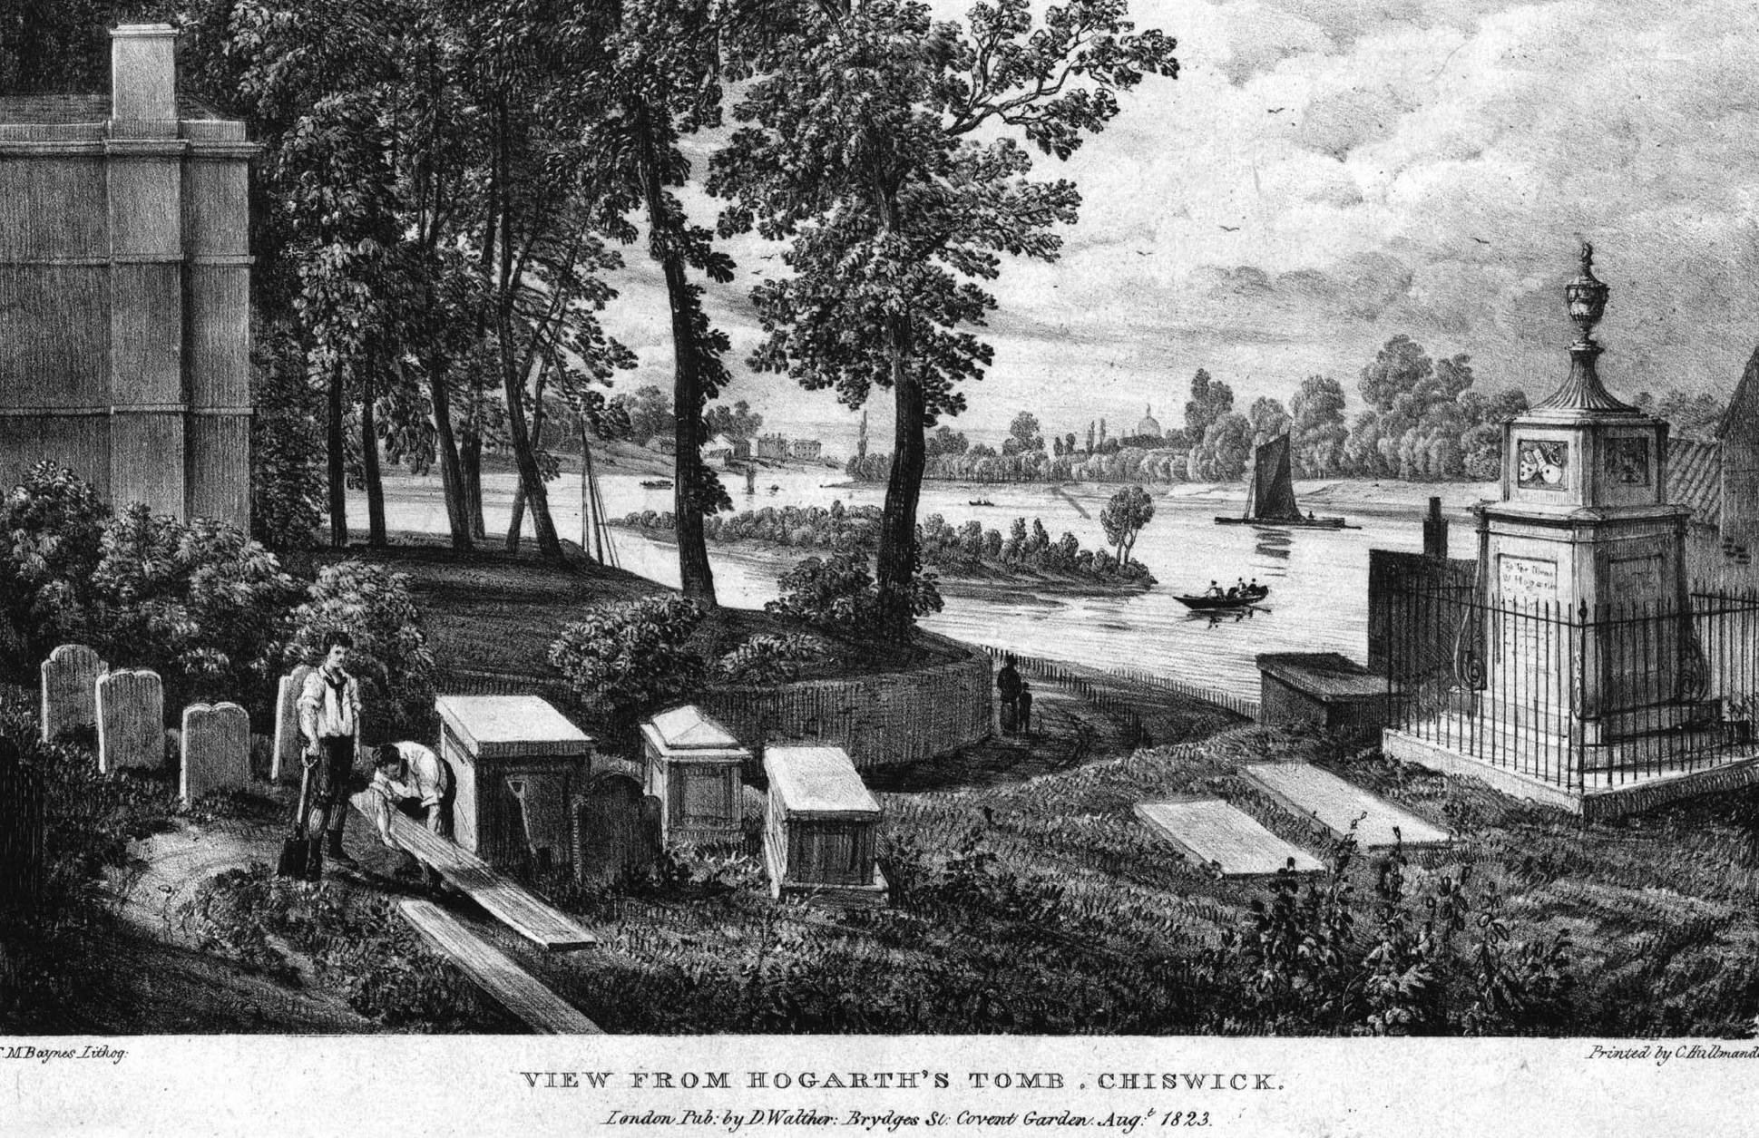
Figure 3 Low trees on Chiswick Eyot which could be coppiced osiers - alongside Hogarth's tomb (1823)

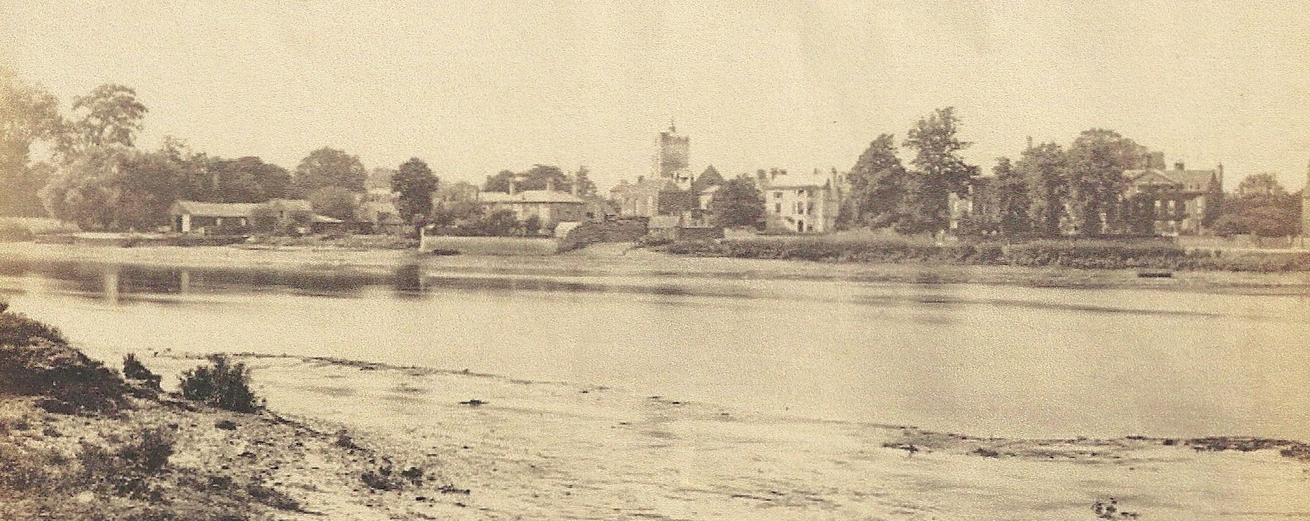
Figure 4 Very low growth on Eyot with Chiswick Mall behind (photographed between 1850s & 1870s)
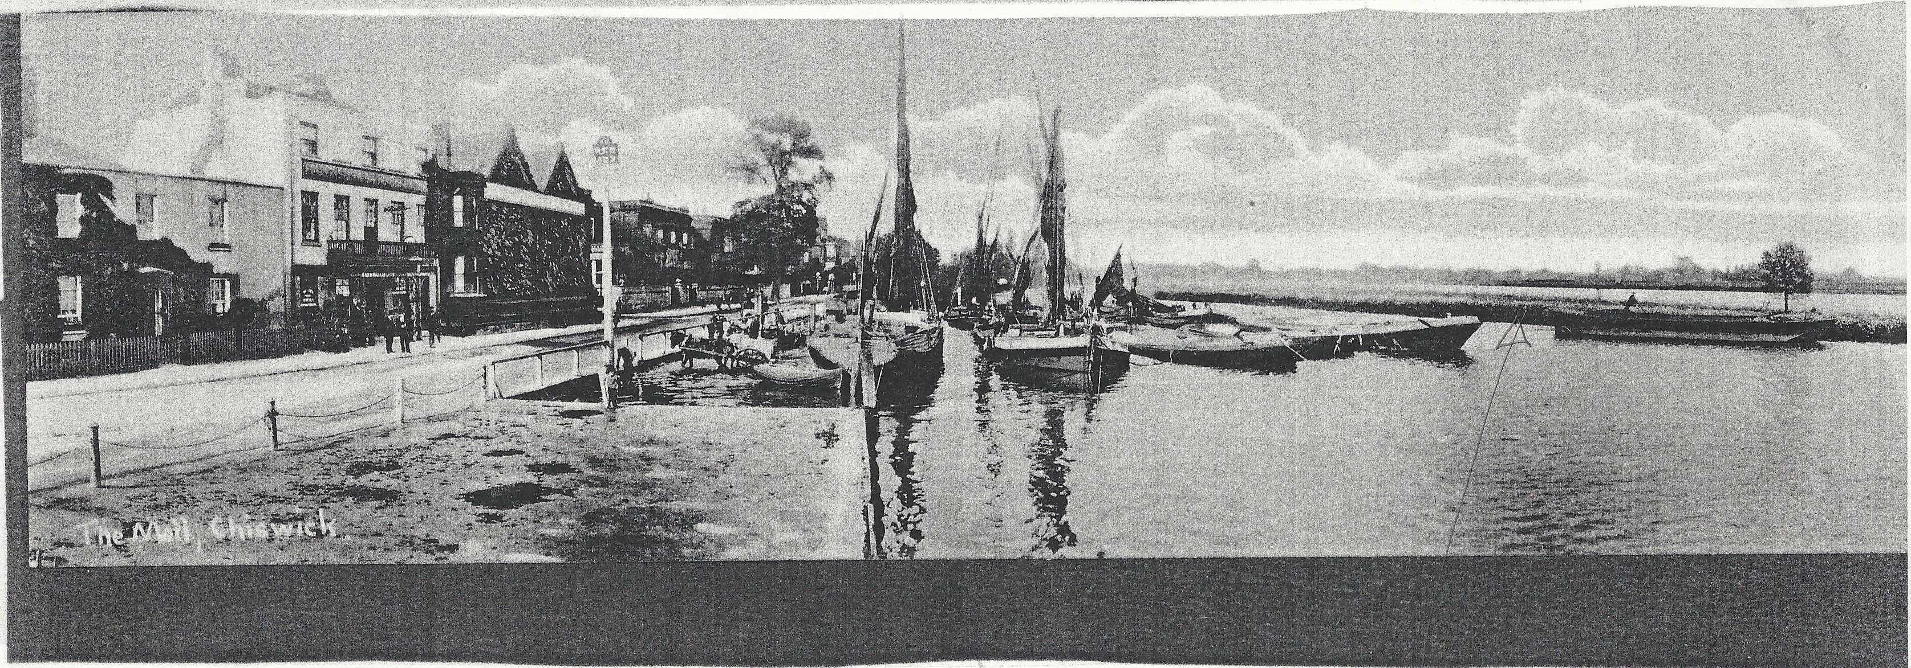
Figure 5 Very low growth on Eyot seen from Chiswick Mall (Photographed before 1913)

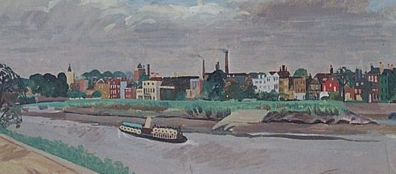
Figure 6 Very low growth on Eyot as painted from Surrey bank (Cronyn 1936)

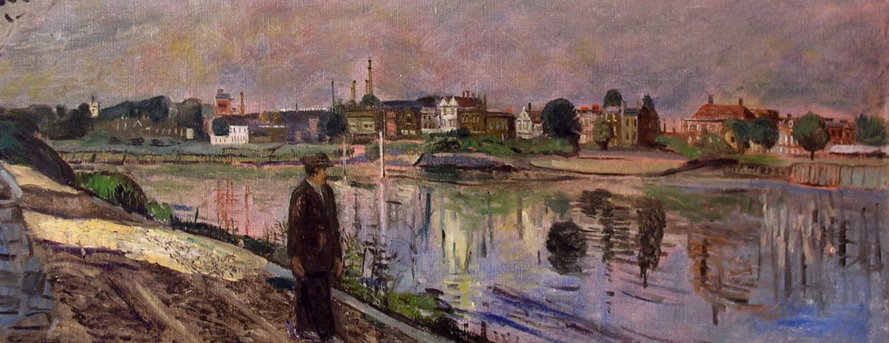
Figure 7 Low growth seen on Eyot painted from Surrey bank (Weight 1950s)

In the original of the photograph in the Local Studies Collection at Chiswick Library shown overleaf (Fig 7), taken sometime between 1884 and 1923, it can be clearly seen that osiers were coppiced annually for withies across almost the entire area of the island.
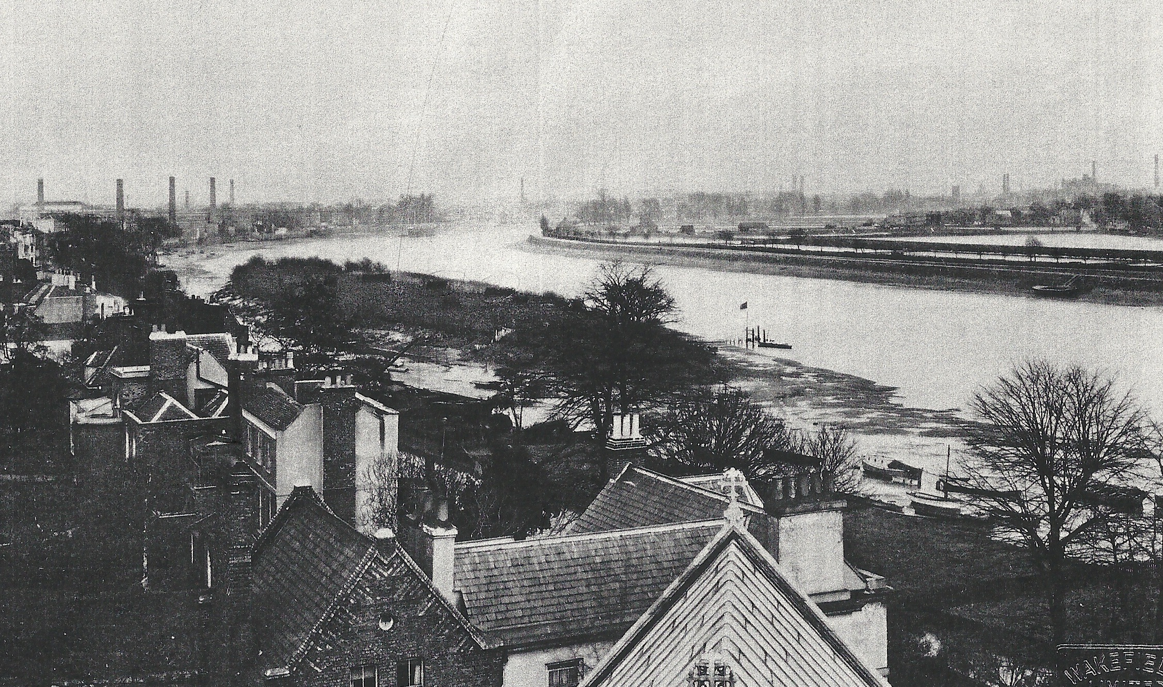
Figure 8 Original of this photograph clearly shows coppicing and stacking of faggots on Chiswick Eyot (taken sometime between 1884 & 1923).

Certainly C.J. Cornish who lived at Orford House reported in 1902, that Chiswick Eyot was ‘entirely planted with osiers’ and that ‘there are standing at the time of writing six stacks of bundles set upright’ As the osiers (harvested willows) were being grown on the Eyot deliberately for the crop of withies, each year some of the cut stems (rods) would have been stuck into the ground to grow into new stools to replace those that had become too old or diseased.

Osiers at other sites were ‘pollarded’; that is, the trunk was allowed to grow some feet tall, and then the branches were left to grow. These were ‘polled’ (Robertson 1895) (harvested) perhaps every three to five years, by which time thickish poles would be cut.

Even though in the past, withy beds were common along rivers including the Thames (Chaplin 1982, Wey Valley 2005-7), Chiswick Eyot is one of the few historic beds that remains (Walpole 2010, Czapski 2011) and the only one on the Thames (Vickers 2012). As a result, it is a very important historical resource.

This importance is reinforced by the fact that the Eyot sits adjacent to the Old Chiswick Conservation Area, one of the first Conservation Areas to be designated in England and one of the country’s richest such areas in terms of historical assets. Many of the houses adjacent to the Eyot will have witnessed the entire history of withy harvesting on the island. The relationship between the townscape of Chiswick Mall and a pollarded or coppiced Eyot is a critical part of the character and appearance of the Conservation Area. By conserving the withy bed together with its context, people can enjoy a largely unchanged historic experience of very great significance.

Role of the OCPS to date
The OCPS has been instrumental in the survival of the historic withy bed by, for 60 years, cutting the withies annually. Coppicing is an extremely labour-intensive and hard task (Robinson 1875) and so when OCPS took over this task after the war, the alternative but equally authentic method of ‘pollarding’ was at some point adopted. Here the trunk of the willow is allowed to grow to about 4 feet and the new flexible growth is cut back each year to the ‘knuckle’. This method is advised today where undergrowth is intense (Baldwin 2005-7) as is the case on the Eyot where labour-intensive weeding has been impossible since the war. Pollarding is also much more convenient for cutting (Welby 2004), especially for volunteers with modern equipment (long-handled shears).

Understanding and enjoyment by users of Chiswick Mall, the river and the towpath on the south bank
Withy beds cut each year have a particular look, the growth of the trees being low, compact and even (whether coppiced or pollarded). This look has meant that this Eyot has retained a very special appearance (Figs 8 and 9).
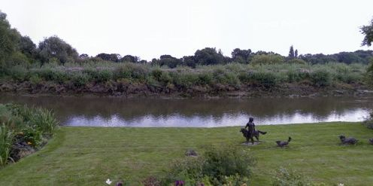
Figure 9 View from Chiswick Mall of even, low, summer growth of annually pollarded osiers
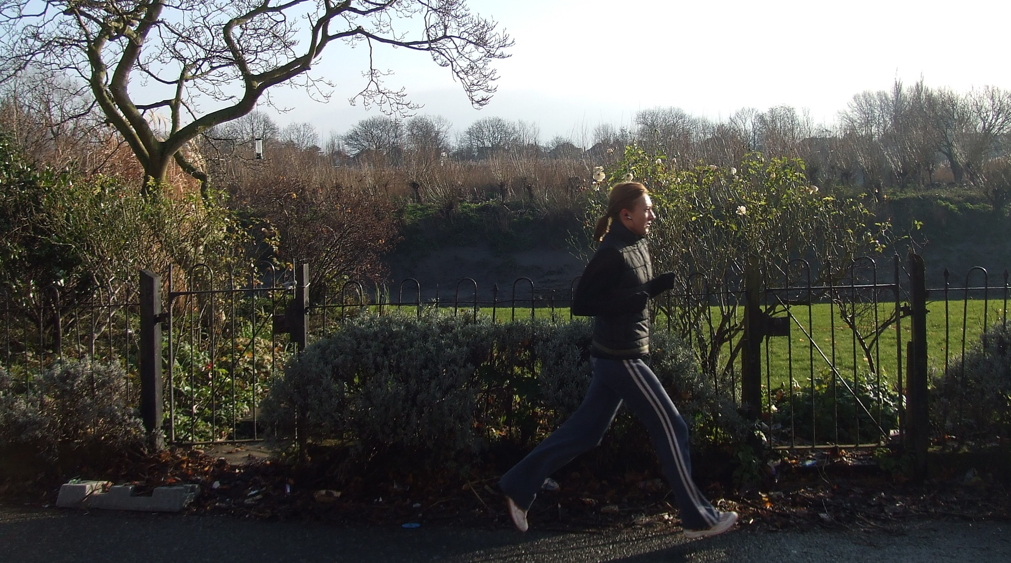
Figure 10 Winter view of annually pollarded osiers from Chiswick Mall
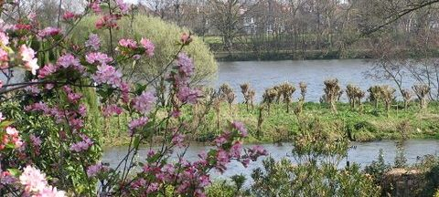
Figure 11 Spring view of uniform ‘pollards’ seen when every osier has been pollarded
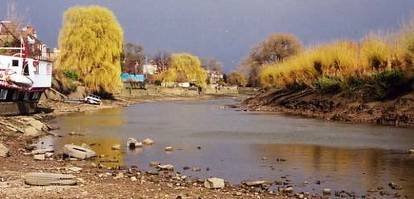
Figure 12 New season’s even growth on annually pollarded osiers from Draw Dock on Chiswick Mall

in contrast with, say, Oliver’s Ait at Strand-on-the-Green where the trees grow untended. As mentioned above, this appearance is vital to the ‘sense of place’ of Old Chiswick and is integral to the preservation of the character and appearance of the Conservation Area. People viewing the unique river scene at the Eyot are ‘seeing history’ as well enjoying a more open (and again historical) view than if the osiers are left to grow for more than a year.

Stabilising the island
There is no doubt that the roots of the osiers have helped prevent major erosion of the Eyot over time. Whilst it could be that if the willow branches are left uncut for a number of years there would be an increased growth in tree roots, it is thought unlikely that this would amount to a measurable amount of increased stability (Crumley 2011). The advice requested by OCPS from an Arboricultural Officer in 2004 also made no mention of pollarding less frequently than annually (Welby 2004).

Much more important for stability has been the role of the concrete revetments installed in the 1960s, and the stakes packed with bundles of green withies (fascines) put in place on the North bank even though these are now failing. Thames 21 has suggested replacing this latter with similar materials: that is fresh withies cut from the island’s trees and bundled into faggots (Thames 21 2011a-b).

Biodiversity
Much emphasis is put these days on increasing Biodiversity wherever possible. It can be argued that Chiswick Eyot as a managed withy bed with a considerable amount of native undergrowth and the other types of trees already present could offer a valuable degree of biodiversity (Crumley 2011). This would be further enhanced if the current invasive species were culled, rotting wood piled up, plastic rubbish removed, and a central high corral above water level for nesting swans etc. was maintained. These are all things proposed by Thames 21 (Thames 21 2010, 2011a-b). The remaining old large trees of various species also need attention (Crumley 2011).

Access and Community value
As Chiswick Eyot is owned by a public body (LBH), these days ‘access’ is important. There are two sorts of ‘access’: physical and intellectual (‘intangible’). As the Eyot floods so often, the ground is extremely muddy and the path up from the drawdock treacherous; physical access for all is therefore not really a possibility. Too much physical access would also prevent the increase of diversity of fauna, especially nesting birds. However, there is always physical access when pollarding or a ‘clean-up’ take place.

Maintaining the look of the Eyot for people’s enjoyment is one aspect of intellectual access; but perhaps more could be offered. OCPS could consider organising talks on the history of the island, for example (Crumley 2011), and creating a strategically placed information board

Pollarding the Eyot over the past six decades has drawn the community together year after year. It is vital that this involvement in the care of the island continues on a local as well as on a wider basis. The withies continue to be used by basket makers (Walpole 2010) but this craft usage could be further encouraged. Certainly the remainder of the withies could be used to help reinforce the island as described above.

Last year, for the first time in recent history, an alternative approach to cutting the osiers was trialled. More selective pollarding was undertaken, with the great majority of the osiers left untouched and allowed to grow, to be cut in three to five years’ time. The growth of the uncut branches has been very significant. The impact of this alternative approach on the character and appearance of the Eyot, and on the important Conservation Area which faces it, has been stark. This loss in significance will only increase if the willows are left unpollarded for yet more years.

The OCPS Position
“The concern of the Society is the maintenance of Chiswick Eyot as a rare example of a traditional withy bed in its historic context”
1. Pollarding
Continue to pollard all osiers annually for withies.
2. Stabilisation
Promote work to stabilise the periphery of the Eyot.
3. Biodiversity
Promote work to continue removing rubbish and invasive species, and to clear old vegetable debris, and attend to large aging trees of all species.
4. Access
Increase intellectual access to Chiswick Eyot, but not physical access except for the necessary tasks above.
5. Community
Continue to engage local communities and develop craft use of withies

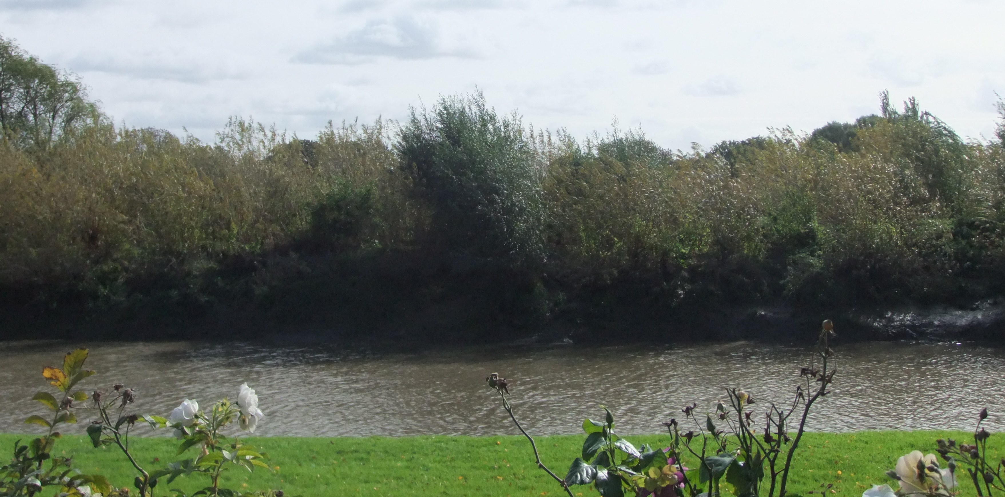Figure 13 Chiswick Eyot from the Mall in September 2011 showing tall, uneven growth of unpollarded osiers

Because many of the osiers were not pollarded in early 2011, the historic significance of the Eyot as a withy bed can much less easily be read or understood by visitors to the Conservation Area.

This document is an updated version paper produced by Janey Cronyn ACR FIIC FRSA (a.k.a. Mrs Stevens - Member of the OCPS Executive Committee) with additional comments by Russell Harris QC (Chair). It was approved at the OCPS Executive Committee Meeting in October 2011.
References/Endnotes

The views given here could form the basis of a more substantial Statement of Significance and eventually a Conservation Management Plan as are encouraged in the heritage field e.g. English Heritage, National Trust.
Clegg, Gillian (1995) Chiswick Past, Historical Publications. More research is in hand by the OCPS.
Three photographs can be found in the Local Studies Collection at Chiswick Library. Some are reproduced e.g. in Clegg (1995); Arthure, H. (2007) Life and Work in Old Chiswick, New Edn., London: OCPS; and Hammond, C. & H. Images of England: Chiswick, Stroud: Nonsuch.
Robinson H.R. (1875) Life on the Upper Thames, London: Virtue, Spalding and Co. ‘Chapter III Osier cutting’ pp. 14-20 (this can be read online at www.archive.org).
Ibid.
Cornish, C.J. (c.1902) The Naturalist on the Thames Available on-line at http://onlinebooks.library.upenn.edu/webbin/gutbook/lookup?num=8682
Robinson (1875) op.cit. Illustration p.7
Chaplin, P.H. (1982) The Thames from Source to Tideway Weybridge: Whittet Books Ltd. Wey Valley (2005-7) Withy Beds (Retrieved from http://www.weyriver.co.uk/theriver/industry_12_withyA.html 6/9/11. Probably written by Ian Baldwin – see Note 11)
Walpole, Lois (2010) Chiswick Eyot Osier Holt (Retrieved from http://loiswalpole.blogspot.com/2010/09/ chiswick-eyot-osier-holt.html 6/9/11. Lois Walpole is a well-known basket-maker) Czapski, Stefan (2011) Old osier bed on Chiswick Eyot (Photograph and caption retrieved from http://www.geograph.org.uk/photo/2231777 6/9/11. The veracity of this information is not known) (Note: Both these sources are anecdotal)
Vickers, Miranda (2012) Eyots and Aits: islands of the River Thames History Press. The author very kindly divulged this information pre-publication.
Baldwin, Ian (2005-7) Cultivating Your Own Withybeds, (Retrieved from http://www.weyriver.co.uk/theriver/industry_12_withyD.html 6/9/11) (Ian Baldwin is a Ranger for Waverley Borough Council, Surrey. He has developed an expertise in cultivating small, craft-based withybeds)
Welby, Mark (2004) Willow Management on the Chiswick Eyot, Copy of letter to Mrs C Brandon, OCPS Archives (Mark Welby was then Arboricultural Officer at CIP Aboricultural Services, Feltham)
Walpole (2010) op.cit.
Crumley, Fiona (2011) Pers. Comm. (i.e. a verbal view) by the Head Gardener at Chiswick House on a visit to the Eyot on 5/9/11 with two OCPS Committee Members. She was recommended to OCPS for an opinion by John Watkins, Head of the Gardens and Landscape Team, Conservation Department, English Heritage.
Welby (2004) op. cit.
Thames 21(2011a) Bulletin: Maintaining Withy Beds. Thames 21 (2011b) Draft of Chiswick Eyot - Habitat Management Plan 2011
Crumley (2011) op. cit.
Thames 21 (2010) Clean-up of Chiswick Eyot organised by Thames 21 12/12/10. Thames 21 (2011a-b) op. cit.
Crumley (2011) op. cit.
Crumley (2011) op. cit.
Walpole (2010) op. cit.
Such work has been proposed by Thames 21 (2011a-b) op. cit.
The first three of these tasks have been proposed by Thames 21 (2011b) op. cit.

