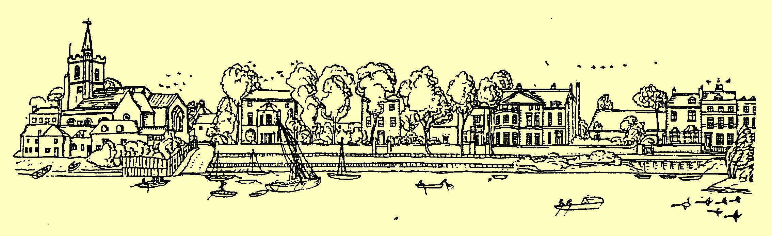
Old Chiswick Protection Society
Autumn 2017 Newsletter
The Old Chiswick Protection Society exists to preserve and enhance the amenities of this riverside conservation area.
Upcoming Events
OCPS AGM 2017 – Monday 13th November at 8pm, refreshments from 7pm
George and Devonshire Pub
The following committee members are due for re-election this year:
Penny Barltrop; Robbie Gill; Patricia Langley; Jane Nissen; Tony Taylor.
We offer for election a new committee member, Rachel Wood.

If you would like to propose someone for election to the Executive Committee, please inform the Secretary by Friday 27th October (Patricia Langley at Riverside House).

The AGM is a great opportunity to meet your neighbours. As they have done year on year, hospitality will be provided by Fuller’s, a truly fine example of good neighbourliness!

New Year 2018 – date to be confirmed
Community bundling day on Chiswick Eyot – all are welcome to help preserve this unique ecosystem!

Chairman's Message
The cool nights and colour-filled days of autumn always show our Old Chiswick Conservation Area at its finest.

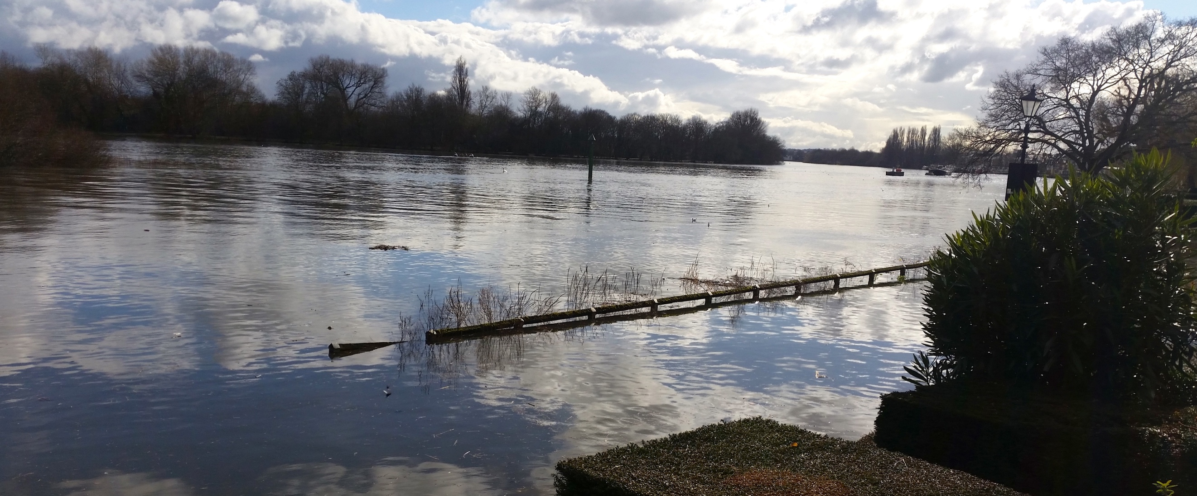

The wildflowers on the Hogarth Roundabout triangle have been flowering late this season, sporadically but beautifully amongst the weeds. However, reluctantly we feel that it is time to say goodbye to our involvement with the triangle and allow Transport for London (TfL) to find a more site-appropriate and climate-appropriate planting scheme. We would like to thank Brita von Schoenaich for her amazing efforts and inspiration on devising and planting the wildflower meadow on the country's biggest roundabout. There is a fuller report below.

Chiswick Eyot, the only eyot left in the tidal Thames with historic withy beds and a nature reserve in its own right, will always need the Society's support in maintaining its uniqueness. Our River sub-committee has worked hard to drum up support for this and will be vigilant on your behalf. The Eyot is eroding. Stronger tides and high rainfall, as well as invasive species, have all conspired against it. It is the subject of a research project at the Natural History Museum – there will be a report in our next Newsletter. The OCPS has striven since its inception to take care of the Eyot and your support is very much appreciated. There will be another traditional Community Bundling Day in the New Year – please come and join us – all are welcome!
There will also be conservation events organised by the charity Thames21, about which we will keep you informed. Keep an eye on our website and social media.

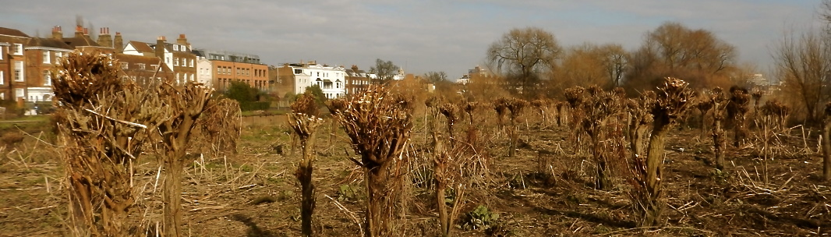

We are extremely fortunate to have an active and long-lived Society, and we are grateful for the continuity and dedication provided by our original Committee Members. Almost every decision we take seems to have a precedent from the past! The OCPS's first meeting took place in early 1958, so next year we hope you will join us in celebrating our diamond jubilee. The date will be in our Spring Newsletter.
The Old Chiswick Conservation Area will be re-appraised as part of Hounslow Council's review of Conservation Area Appraisals. The OCPS intends to take an active part. The Council is also re-visiting the Local List (locally listed buildings) and will be inviting suggestions for any new additions.
Chiswick Gate Development at the Hogarth Roundabout
This development is nearing completion. The OCPS has raised concerns over the impact on traffic volume and its management. The development comprises 171 dwellings, including 52 affordable homes. The site sits on a huge subterranean car park for use by residents only, but it appears to cost an additional £35,000 to purchase a parking space in this garage.

There is no vehicular access at ground level to any property. All visiting vehicles will have to park in very limited ground-level space, including all delivery vehicles and guests. Goods will have to be trollied to homes along pedestrian walkways. Inevitably, many visitors will find pay parking in nearby streets such as Church Street or Paxton Road. It is some relief that Hounslow Council has refused residents’ parking permits to estate residents.

The OCPS and local Councillor John Todd are considering the implications of Paxton Road residents requesting a separate sub-zone of the CPZ scheme. Paxton and surrounding roads are already taking a considerable parking overflow from the new development and the new Premier Inn hotel. OCPS has written to Hounslow Council giving our views and many residents have received a Council communication asking for their views on changes to the existing parking arrangements.

The site, including the Premier Inn hotel, will also have an impact on traffic. There is only one east-bound exit from the site, with no access to the flyover. Therefore, there are likely to be major tailbacks onto the narrow and crowded slip road onto the roundabout from the A316, negatively impacting local traffic. Hounslow Council raised no concerns, possibly as it is the remit of Transport for London (TfL). TfL will not agree to restrict the main A4 westward traffic flow to reduce the impact on local residents.
Since 2014, the OCPS has also been in contact with TfL regarding proposed improvements to the subway under the Hogarth Roundabout. These will address the increased pedestrian and cycle traffic to and from Chiswick Gate and the new offices to be built at One Burlington Lane. The latest update is that TfL is waiting for a budget resolution with Hounslow Council and for the plans to be finalised. The final plans intend to include Legible London signage.
Hounslow Council Heritage Street Lighting Replacement
Hounslow Council and Hounslow Highways will soon be undertaking a programme of replacing all existing heritage light columns with newer equivalents. This programme will replace approximately 376 light columns in Chiswick, Isleworth, Brentford and Heston. These will use DW Windsor columns with four-sided luminaires, containing textured panes and an LED light source. The columns will match the height of the existing columns. The exceptions are the Heritage Style lighting columns along Strand on the Green, which are currently being tested for Safety and Integrity, as they are subject to a protected status, and some columns along Boston Manor Road as they are unique in nature.

The OCPS was consulted on this subject. While we didn't achieve all requests, the approved Council Cabinet paper took the majority of our recommendations into consideration and allayed most of our concerns, in particular by using “like-for-like” replacement columns. The replacement programme has begun in the Bedford Park area of Chiswick and will progress west towards Heston. The new lamp columns in Bedford Park are reported as being taller than the existing ones, and we have still to confirm with Hounslow Highways whether our three "REVO" lamp columns will be retained.

Meeting with Fuller’s Brewery

Residents reported an increasing number of heavy vehicles visiting the brewery, arriving “out of window” and parking without consideration. This was particularly in Netheravon Road South. Our Roads and Traffic sub-committee discussed this, and other matters, with Peter Turner of Fuller’s.

Peter told us that the problem was already being addressed and improvements are in hand. Equipment is being installed to speed up the unloading of lorries. Long-term wine storage is being transferred to warehouses outside London. All other export traffic will be transferred to Marston’s, their contractor in the country. Small loads will now be delivered in smaller vehicles. Fuller’s are clamping down on visiting vehicles being left unattended, obstructing residents’ access and parking.

Many first-time visiting drivers come from abroad and are inadequately briefed on matters of access. The possibility of using Heston Services as a staging post is being considered, where the vehicles can be held until forecourt space becomes available.

Damage resulting from heavy vehicles parking on the recently refurbished kerbs and footpaths is being monitored.

In case of any future problems, we are advised to call Fuller’s reception on 020 8996 2000.

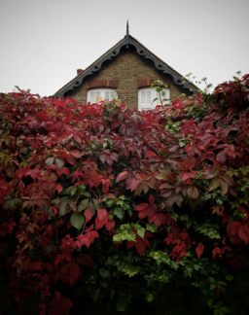

Tesla Motors Ltd
Tesla appealed a Borough decision that it was in breach of planning regarding its illuminated advertising on the Hogarth Roundabout. The issues are the impact of the illuminated advertisements on the character and appearance of the area and that, after dark, the lighting is distracting to drivers.

The OCPS informed Hounslow Council of our view that the Tesla lighting is harmful to the Conservation Area, in particular Chiswick Square, Boston House and Church Street. It may also set a precedent with both signage and additional lighting of other local commercial buildings. Examples include the Premier Inn and the new development proposed for One Burlington Lane. The inspector noted that the illuminated signs were already in place and so this was a retrospective matter. The OCPS is pleased to report that the appeal was dismissed and we can now expect that the levels of illumination will be reduced.

Advertising Vehicles in Mawson Lane
For many years the OCPS has dealt with the removal of these vehicles. New legislation to re-enforce this removal has been adopted by Hounslow Council. Fuller’s, whose staff benefit substantially from this process, has now agreed to take over responsibility.
Refurbishment of Netheravon Road South Footpaths
It was good to say goodbye to the broken flagstones and black tarmac in-fills when Hounslow Highways set about repaving our footpaths. The workforce made every attempt to minimise inconvenience, even though the initial notice indicated that parking and access would be interrupted throughout the whole of the anticipated 21 working days. In the event, the project substantially overran and through its latter stages the workforce was augmented and the tempo increased. We have concerns about the quality of the materials and the work done during that time. Discussions continue with Hounslow Highways and their contractors to decide what improvements can be made.

Hogarth Triangle
Sadly, the wildflower triangle, which looked so lovely last year, did not succeed well in 2017. There has been intermittent success in recent years and Brita von Schoenaich, the wildflower expert who has so generously given her service over many years, is contemplating giving up planting the triangle. She says:

"I think that statistics on urban heat canyons and change in weather patterns, as well as traffic increase, are related to the increasing failure of the wildflower triangle. Since I first started planting it about 18 years ago, rain patterns are less predictable: there are longer periods of drought and then heavy downpours with water that cannot be retained in this poor and sandy soil. More continuous traffic jams result in more heat, and there is virtually no dew on this little sliver of land between the cars.
With regard to the timing of sowing this year, we had a very dry spell in early June and a long period with no rain in July. It was the latter that killed off our seedlings, which were about 5cm tall at the time. Had they been sown earlier, they would have started to flower at that stage – but I am not sure if they would have survived 32C and no rain for 3 weeks. The weeds that have taken over the triangle are very drought-tolerant short-lived perennials. They will always come up, no matter when the triangle is rotavated. It is really sad to consider giving this up, and for me it is the end of an important experiment that has informed our work as well.”

We are talking further to Brita about the future of the triangle – she has some suggestions to make to TfL about alternative maintenance. For the moment, we feel greatly in her debt for all she has done in the name of the Society.

Books on Old Chiswick
The books published by the OCPS on the history of Old Chiswick and on the Thornycroft Works are on sale at Hogarth House as well as at Bookcase and Waterstones in Chiswick High Road. They can also be obtained from Rosemarie Clifton, Brampton House, Church Street.

Website, Social Media and Email Address
The OCPS website is updated regularly. It is full of information on the history of old Chiswick, as well as on current events and it has many useful links. Do have a look at it: http://www.ocps.btck.co.uk

We are always looking for more photos old and new of the area, so please do share any you might have on:
Instagram@oldchiswick https://www.instagram.com/oldchiswick/

You can also find us on Facebook and Twitter:
Facebook Old Chiswick Protection Society https://www.facebook.com/OldChiswick/
Twitter @old_chiswick https://mobile.twitter.com/old_chiswick

And of course, you can always email us at: oldchiswick@googlemail.com

Names and Addresses of Officers
President Sir Alan Munro, Eynham House, Chiswick Mall
Chairman Mrs Penny Barltrop, October House, Church Street
Treasurer Mrs Rajpreet Bains, The Hollies, Netheravon Road South
Secretary Mrs Patricia Langley, Riverside House, Chiswick Mall

