Old Chiswick Protection Society
The Old Chiswick Protection Society exists to preserve and enhance the amenities of this riverside conservation area.

Spring 2016 Newsletter
Two parties!
OCPS summer party – Tuesday 5th July
The OCPS summer party has proved to be a very popular event. We’re holding another one this summer and do hope you will join us on Tuesday 5th July at 6.00pm at Eynham House, Chiswick Mall, by very kind invitation again of Sir Alan and Lady Munro. Please bring something delicious to eat or drink.
Church Street street party – Saturday 12th June
The ‘Alternative’ Mall Party (the same day as the Buckingham Palace Mall celebrations for the Queen’s 90th birthday) will be open to all. Please see the end of this Newsletter for more details.

Chairman’s message
I'd like firstly to thank you all for your support of my Chairmanship, and secondly to express the Executive Committee's thanks to Russell Harris for an outstanding incumbency. His commitment to and appreciation of our lovely Conservation Area has been evident throughout his term and we are fortunate to retain his knowledge and experience as he continues as a Committee member.

The Old Chiswick Protection Society was founded in 1957, thanks to the hard work of our predecessors, for the purpose of protecting and enhancing the area. In 1967 we became one of the first Conservation Areas in the country, and OCPS became a Charity in 1985.

Since then the environment on all sides has changed, and continues to change a great deal, yet all the while, with our help, Old Chiswick has retained, for everyone's enjoyment, its historic mix of industrial and residential buildings in a beautiful riverside setting, when many other parts of London have irretrievably lost theirs.

From the beginning of last year, Hounslow Council have made significant changes to the Borough street scene with renewal of street lighting, paving and the introduction of wheelie bins. We have lost York paving and heritage lamp posts from several of our streets over the past decades, and we must be vigilant in retaining what's left.

Membership
We do hope you'll renew your membership, or consider joining us. We have a yearly commitment to the professional pollarding of the Eyot, to maintain it as an historic withy bed. We provide wildflower seeds for the triangle on the Hogarth Roundabout. And we contribute to restoration projects in the conservation area, such as work on tombs in the churchyard. Subscriptions are just £15 per person per year and are due now. Many of our members have been asking for a standing order form, so we now have one attached to the membership form with this Newsletter. Please complete both forms if you are setting up a standing order.

Website and email address
The OCPS website is updated regularly. It is full of information on the history of Old Chiswick as well as on current events, and it has many useful links. Do have a look at it: http://www.ocps.btck.co.uk
The OCPS can be reached at oldchiswick@googlemail.com

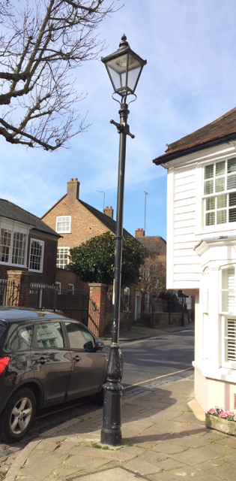
Hounslow borough-wide replacement programmes

Street lighting
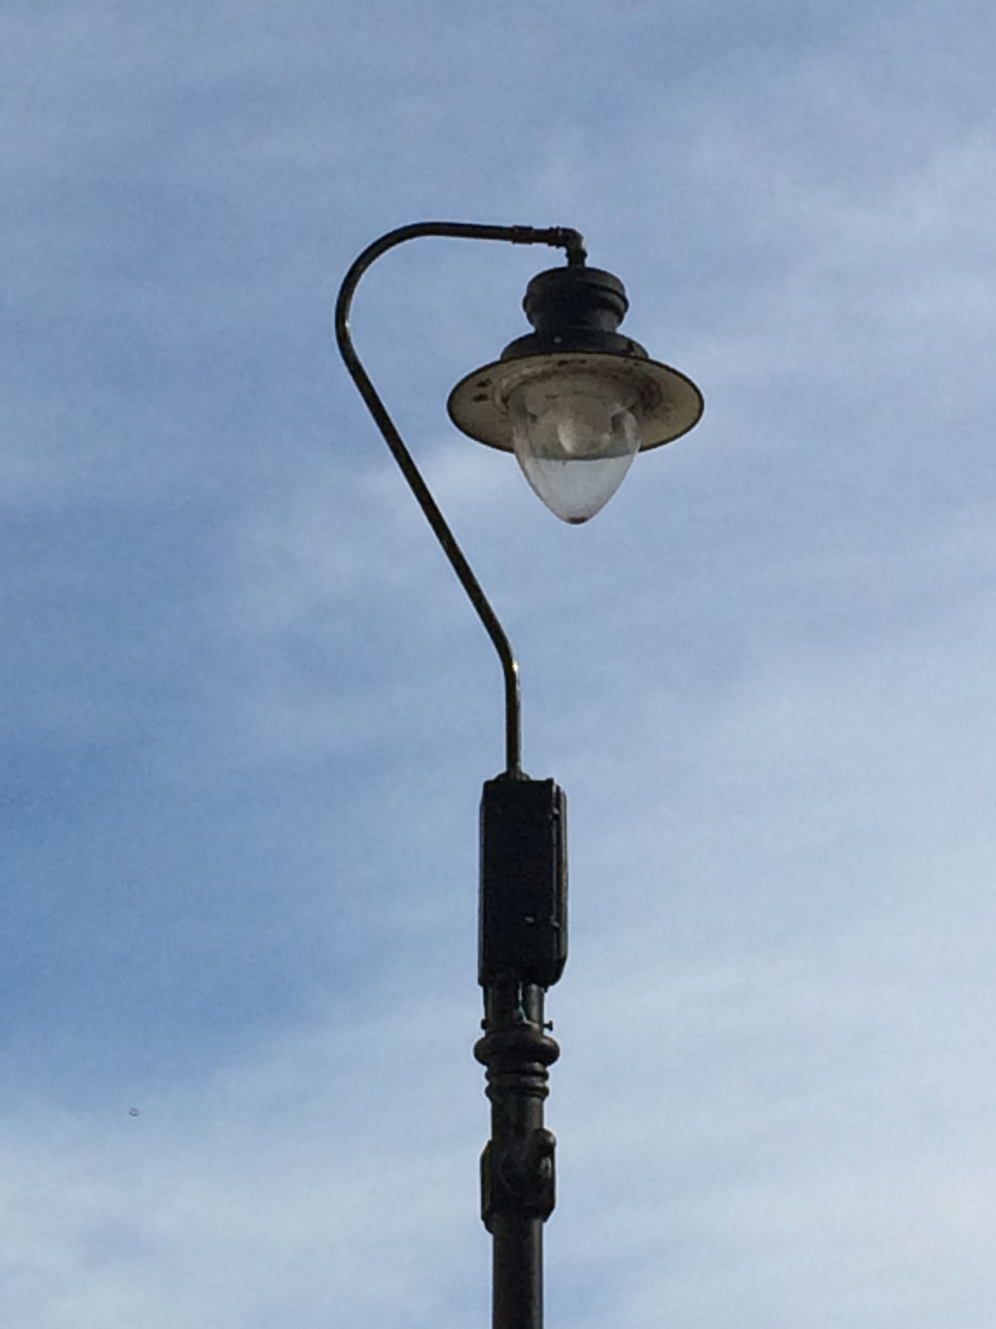
As we have reported in recent Newsletters, we are fortunate to still have old style lighting columns in much of Old Chiswick. These have swan-neck street ‘luminaires’ along Chiswick Mall, and lantern-style ‘luminaires’ in Church Street, Church Walk and the east end of Pumping Station Road. When Hounslow Council proposed replacing "heritage lighting" with LED lights and new columns as part of their street-light modernisation programme, we fought hard to retain the existing columns, and campaigned for a softer light to complement the Conservation Area. We believe at least some of our arguments have been heard but we still wait to hear details and confirmation. Because the lights on Chiswick Lane South, Netheravon Road South, Airedale Avenue South, British Grove South and Powell's Walk were not “heritage”, without any discussion, last year the Council replaced them with the new tall standard LED posts and lights. In theory, residents can request the light levels of these to be turned down if they are causing a nuisance. Go to the following website link on the Hounslow Council website to report this problem: http://www.hounslowhighways.org/38-contact-us.html. More on our “heritage” lights can be found under the ‘About Old Chiswick’ tab, ‘resources’ page on our website.

Wheelie bins for household waste
The difficulty with these bins in Conservation Areas is that not all households are able to store them off the street out of sight. Historic England has identified the impact of such bins as unsightly and significantly harmful to areas such as Old Chiswick, where the combination of historic buildings and street furniture is a key element of ‘significance’. Unfortunately the Conservation Officer at Hounslow Council has deemed wheelie bins acceptable.
A further problem with bins left on Chiswick Mall is that the tide will pick them up and move them along the road and into the river. OCPS has therefore agreed with Council Officers that Chiswick Mall and Eyot Green will not have wheelie bins, but will remain on black plastic bags, and sacks for the new paid service for garden waste.

Paving
Hounslow Council contractors have renewed pavements in the Old Chiswick area. Their programme only covers paving which is not currently York Stone. British Grove South was done in April while Netheravon Road South is not due for replacement until 2017. The Council have said they would undertake to repair York Stone paving and where necessary replace with York Stone. However, we have been alerted to the fact that they are running out of York Stone so we must remain vigilant in ensuring that the York Stones along Church Street, Chiswick Mall, Church Walk and the eastern portion of Powell's Walk are not replaced by non-York Stones.

Planning
There has been no planning application of any consequence within the conservation area recently, but there is an application that will affect it. Axis House, overlooking the Hogarth Roundabout, is actually two buildings, one facing onto the A4 and the other facing onto Burlington Lane. An application to change the use of the part of Axis House overlooking the A4 has been successful: it will be converted from offices into a Premier Inn. We consider that this will have not a meaningful impact as the appearance will be the same (if slightly softened by additional planting) and there is likely to be an overall reduction in traffic. The part of Axis House facing Burlington Lane is of a greater concern. An application has been made to demolish the existing building and build an office building. In design terms it is a little heavy but much more attractive than the current edifice. The concern is that it will be 29.75 metres high, which is approximately 7 metres higher than the current office building. It will therefore further overlook the properties on Church Street. The OCPS has objected to the application on these grounds.

Port of London Authority towpath treeworks 2016
The PLA undertook tree works over the winter on the Barnes towpath, with the health of the trees and the structural integrity of the revetment wall as the main criteria. No work was necessary on the towpath trees opposite our Conservation Area. The PLA has kept us informed throughout and we welcome this co-operation. The PLA draw up their plans for next winter’s works in June, so suitable re-planting areas will be decided on by the end of May and the OCPS will have an opportunity for input. However, there was felling on the towpath in the Putney area over the winter, in mitigation for wind loss due to the possible extension of the Fulham Football club. This is something to be watched carefully in our area. The rowing and sailing lobby is a strong one. Accordingly, members of the OCPS have attended several PLA meetings during the past months.

Traffic and roads

Homefields South Park Improvements
All the works which were due to start at the time of our last Newsletter have now been completed so that with the arrival of spring we begin to see the benefits. Most of the pathway has been levelled and resurfaced, more trees planted, the beech hedge extended, railings reset and painted, brickwork repaired. We still continue to press for further improvements for which Hounslow Council tell us additional funding is being sought, including a more attractive surface for the path, new benches and more litter bins.

Hogarth traffic lights
Periodically Transport for London re-phase these lights with the result that we lose the valuable 3-second interval which allows traffic from Church Street to join the flow onto the roundabout. This real hazard for residents happened in February. Following our representations, the interval was restored; we have re-asserted the dangers if it were to happen again.

Extra parking space in Church Street
An OCPS member pointed out at a recent AGM that a parking space had gone missing outside his house in Church Street. A complaint was lodged with Hounslow Council, which visited the site to review the parking arrangements. After considerable due process (and apologies for several delays), we can report that the Council received no objections from the emergency services to the proposed parking amendment in Church Street, this being an extension of the shared-use parking bay along the side of The Old Vicarage. Hounslow Highways will undertake the necessary amendment to the on-street markings and will also advise Hounslow Council on the cost and timescale. The Council tend to allow 4-6 weeks after accepting a quote from Hounslow Highways so, as an initial estimate, the amended shared-use bay could be in situ sometime in June 2016.

Powell’s Walk or Chiswick Wharf?
Google Maps showed both pedestrian paths leading to Church Street on either side of the Church as Powell’s Walk. The southern one is in fact Chiswick Wharf. The OCPS corrected the mistake by arranging Google maps to accept the change after a certain interval when no objections were reported.

Hogarth Triangle
This will be the sixth year that the OCPS has supported Transport for London in maintaining the triangle at the Hogarth Roundabout. The objective has been to create a wildflower garden – not an easy task, but with the aid of Brita von Shoenaich, the noted wildflower expert who kindly gives her services to us, we have had some notable successes in the past (and Brita has been complimented by the Prince of Wales for her efforts).
Last year, high winds at the time of sowing led to poor germination. This year TfL has sprayed, strimmed and rotavated according to Brita's schedule, and seeds were sown in early March. We wait in hope for a floriferous triangle this summer.

Swifts
Did you know that swifts’ closest relatives are humming birds? Sadly, swifts have suffered a dramatic loss of nesting sites thanks to our extensive re-roofing, insulation, renovations, loft conversions, and the demolition of old buildings. Although swifts are here only from May to July, our towns and villages are their real ‘home’: they return with the same mate to the same building and the exact same nest site every year. They then fly the 7,000 miles back to central and southern Africa, where they spend the other nine months of the year on the wing. However, every year, fewer of their homes in cavities in eaves or under tiles survive. The RSPB, with Swift Conservation and other wildlife organisations, would like us all to put up nest boxes or ’swift bricks’ wherever practicable. Chiswick Eyot was being considered as a possible site for nest boxes as part of the revitalization of the Thames as a natural corridor for wildlife, so we attended a meeting hosted by the RSPB and Hounslow Council’s Ecologist to discuss this. However, the Eyot is not ideal as boxes there would have to be on tall poles, with strong foundations to resist the tides. But in other local sites – St Nicholas' Church, Fuller’s Brewery, private houses – nesting boxes could be affixed in small groups or pairs (swifts like the company of other swifts). Catherine Day, a local RSPB volunteer, is investigating, and has had very positive responses from the Church and from Fuller’s. If you would like to know more, or volunteer to record sightings of swifts in Chiswick this summer, or put up nesting boxes on your house (there are many designs and types to choose from), please contact Catherine: catherine.day.lacia@btinternet.com

The Eyot

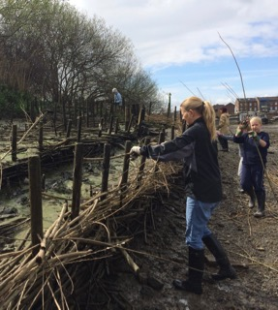
Work on the banks
Thanks to all our volunteers, we’ve done a lot of work building up the banks of the Eyot, and have used up all the withies cut by the professional pollarders. As you know – since this is a perennial topic in this Newsletter – we are fighting an on-going battle against the forces of nature (tides and Chinese Mitten Crabs). We need all the help you can offer – do keep an eye on the website for times when we are working on the Eyot. We will also send out emails to everyone whose address we have.

Reed beds
These are more edangered than we realised – again, from the burrowing of Chinese Mitten Crabs and the force of the tides. This is not work that can be done by volunteers, so a plan is being drawn up by Hounslow Council for defences to be installed professionally, using large willow branches which will be pinned in place and take root, creating a barrier in front of the reeds.

Himalayan Balsam
This has also become rather too big a job for sporadic volunteer efforts. So while we wait (and hope) for a recently discovered pathogen to become available, Hounslow Council have undertaken to cut the Balsam back with powered tools. This will weaken it sufficiently to allow other plants to thrive and, at least in some places, to outcompete the Balsam.

Natural History Museum
This research project has now begun – it will give us a great deal of information on the actual damage that the Chinese Mitten Crab is causing and on the extent and speed of erosion. For more information, see: http://www.savingchiswickeyot.com/

Books on Old Chiswick
The books published by the OCPS on the history of Old Chiswick and on the Thornycroft Works are on sale at Hogarth House as well as at Bookcase and Waterstones in Chiswick High Road. They can also be obtained from Rosemarie Clifton, Brampton House, Church Street.

Names and addresses of officers
President Sir Alan Munro, Eynham House, Chiswick Mall; Chairman Mrs Penny Barltrop, October House, Church Street; Treasurer Mrs Rajpreet Bains, The Hollies, Netheravon Road South; Secretary Mrs Patricia Langley, Riverside House, Chiswick Mall

Street party: Sunday 12th June – midday to 6pm
This traditional street party is being organised by Ali Philips of Thames View House, Chiswick Mall. It will be open to all, for fun, celebration and community, and to raise funds for the St. Nicholas’ Church Development Appeal. The local police have indicated their willingness to join in the fun. There will be cakes, sandwiches and refreshments and a number of side attractions. Fuller’s will generously donate a substantial quantity of beer and some equipment.
Chiswick Mall will be closed from the bottom of Church Street to the bottom of Chiswick Lane South.
Ali hopes local residents who wish to help or be involved will get in contact: Alipphilips@aol.com

